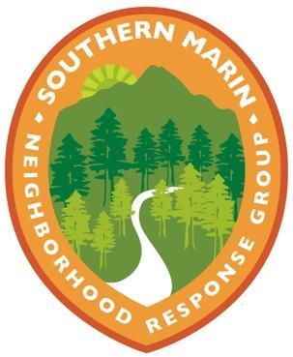
Southern Marin
Neighborhood Response Group

Dear Neighbor,

My name is [Your Name]. I am a volunteer Block Captain with the Southern Marin Neighborhood Response Group and excited to share some of the emergency preparedness resources we have access to through the Southern Marin Fire Protection District. The Neighborhood Response Group program is a grassroots, neighbors-helping-neighbors effort that aims to connect, educate, and better prepare neighborhoods for disasters and emergencies.

When disasters happen, neighbors will turn to neighbors for help. That’s why it’s important we do our part to connect with each other, find out where the greatest needs are, and who can offer support when disasters happen. Once Block Captains make sure their own households are safe, we step up to check on our neighbors and help, when possible.

What can neighbors do?
Neighbors who don’t volunteer in the program also have a part to play in emergency preparedness. You can display your OK/HELP sign during our twice-yearly drills, fill out the Resident Information Form to share basic contact info and safety concerns/resources with your Block Captain, and help spread the word.

Let’s Connect
As one of the Block Captains in our neighborhood, I wanted to let you know more about the program and support that’s offered. If you’re interested in learning more, please reach out to me or visit southernmarinnrg.org for more information.

Thank you for helping make our neighborhood a safer, more resilient place!

[Your Name]
Southern Marin Neighborhood Response Group Block Captain
Email:
Phone:
Address: [if you choose to disclose]

